Control Engineering

Handout – Online Laboratory 12

Name: *Colda Andreea Ariana*

Group: *30332*

Consider the multivariable system with 2 inputs (u1 and u2) and 2 outputs (y1 and y2):

where the process is G(s)= $\left[\begin{matrix}\frac{0.4}{3s+1} & \frac{2}{5s+1} \\ \frac{2.5}{10s+1} & \frac{0.1}{7s+1}\end{matrix}\right]=\left[\begin{matrix}G_{11}(s) & G_{12}(s) \\ G_{21}(s) & G_{22}(s)\end{matrix}\right]$. For this multivariable system, a decentralised control approach has been applied to this process in Laboratory 11.

Design a decoupler and then the controllers such that:

* for y1(s) an overshoot of 10% and a settling time of 1s are obtained
* for y2(s) an overshoot of 5% and a settling time of 10s are obtained

Analyse the closed loop dynamics and verify that the performance specifications are met. Compare your results with the decentralised control approach.

*Specify the input/output pairs*

Hf1\*(s) = -Hf1(s)

Hf2\*(s) = -Hf2(s)

*Add the obtained controllers*

*4.6403 (s+0.3333) (s+0.2)*

*Gc1 = -------------------------*

*s (s+0.3351) (s+8)*

*0.3647 (s+0.1429) (s+0.1)*

*Gc2 = -------------------------*

*s (s+0.1434) (s+1)*

*Add graphical proof of the performance (y1, y2 plots).*

*Comparison with the decentralized control approach (y1, y2 plots)*

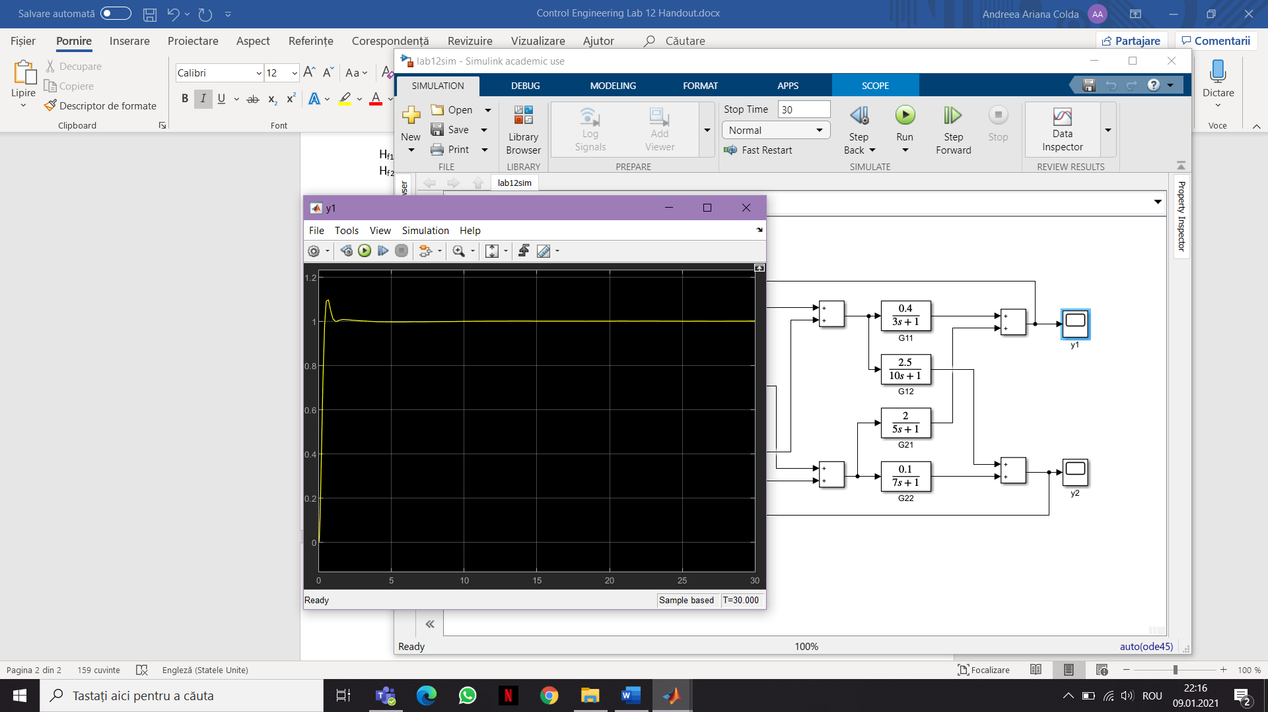

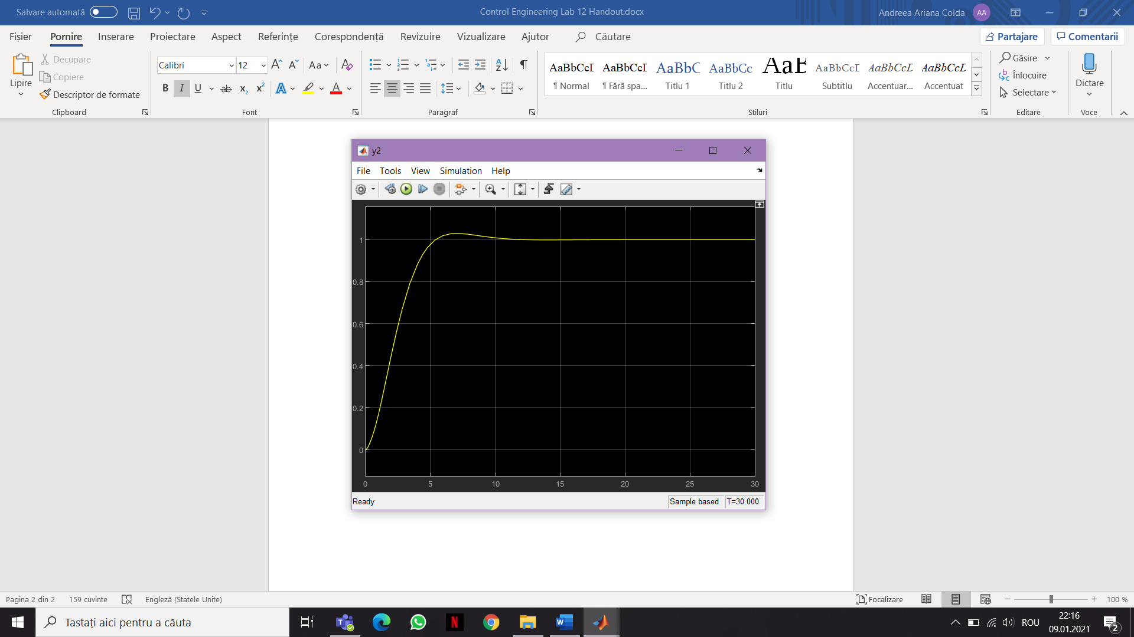

*Comparison*

*Decentralized control*

